100m Mannen Reeksen Time :10:46
Heat:1 Wind : 4.2
1 2329 VRANKEN ANDREAS 93 DCLA 10.69 Q
2 798 SAERENS MAARTEN 00 HAKI 10.92 q
3 3372 MATHIJS BENJAMIEN 93 ACA 10.96 q
4 3041 SCHELDEMAN YESTIN 91 RCG 10.97 q
5 789 VAN GESTEL MATTHIAS 01 ACHL 11.13
6 768 MALUMGRE WARD 00 LOOI 11.18
7 2735 SCHEPERS ARNE 99 AVT 11.29
Heat:2 Wind : 2.0
1 531 KERKHOFS NIELS 01 AVT 10.91 Q
2 2254 HOFMANS VICTOR 94 OLSE 10.91 q
3 3215 MOTMANS GLENN 94 AVT 11.15
4 2963 DE PAUW BRENT 93 ACHL 11.17
5 839 BUFFEL SIMON 01 RCG 11.18
6 3188 ROOFTHOOFT ANDREAS 96 RCT 11.23
7 2614 BLOKKEN DELSIN 99 GENK 11.69
Heat:3 Wind : 2.1
1 477 VERGAELEN DRIES 00 RCG 10.97 Q
2 3511 VAN HECKE CHRISTOPHE 91 EA 11.05 q
3 3326 WAGEMANS SOREN 97 VAC 11.09
4 2256 CALLUY DYLAN 94 OLSE 11.13
5 2992 RENSON MASSIMO 96 FLAC 11.15
6 2544 DU PAN TOM 89 ACME 11.28
7 1275 SIJBERS SASHA 04 SACN 11.88

100m Vrouwen Reeksen Time :10:56
Heat:1 Wind : 0.5
1 482 ROSIUS RANI 00 AVT 11.95 Q
2 3826 HEYVAERT LUCA 02 LEBB 12.42 q
3 2290 HELLEMANS SASKIA 96 VOLH 12.48
4 2018 BEYLEMANS LAURA 97 ACME 12.49
5 2294 STAPPERS FLORE - 91 95 FLAC 12.49
6 926 KEGELS MARGOT 01 VAC 12.99
7 1823 BROEKHOVEN SASKIA 98 LOOI 13.89
Heat:2 Wind : 2.5
1 646 GOOSSENS JUSTINE 00 RCG 11.99 Q
2 817 VINCKE RANI 00 HAC 12.03 q
3 2017 BEYLEMANS JOKE 99 ACME 12.28 q
4 2535 KASSIMA TABITA 96 BVAC 12.39 q
5 1556 LAMMENS LISA 98 ACME 12.68
6 1309 HEYVAERT ELLA 05 LEBB 12.91
7 532 HIEL EMMA 01 LEBB 13.57
Heat:3 Wind : 2.1
1 793 DE FOER LOTTE 00 ACW 12.08 Q
2 465 VAN LENT LOTTE 01 AVZK 12.17 q
3 2481 ASOMANING STEPHANIE 90 KAAG 12.61
4 2165 KINABLE CHARLOTTE 98 ROBA 12.71
5 2239 COPPENOLLE EMMA 96 DEIN 12.74
6 706 VANDERWEGEN LORE 00 ROBA 12.90
7 2129 MERGAN TINA 99 LEBB 13.31
8 861 VANHEST AUKJE 01 LOOI 13.65

5000m Vrouwen Time :11:21
1 2093 DALEMANS ELINE 91 AVLO 16:51.04 KVV 1
2 1790 TACK LORE 87 BRAB 17:02.07 KVV 2
3 2042 VAN HESE CHARLOTTE 95 AVLO 17:17.22 KVV 3
4 1570 ROOMS VALERIE 96 LAT 17:20.23
5 2287 SMET KAROLIEN 85 VOLH 17:48.31
6 2226 SCHEERENS ELISE 94 LYRA 18:03.39
7 1590 DE SCHAEPMEESTER JOLIEN 97 RCG 18:10.16
8 2490 VANDEMOORTELE JOLIEN 96 HULS 18:30.87
1779 TJEERDSMA MARISKA* 92 LEBB DNF
4330 DE CUPERE KATLEEN 80 RCT DNF

hinkstap Vrouwen Time :11:37
1 2230 LENCHANT SIETSKE 93 ROBA 12.57 +2.0 KVV 1
2 512 DELBARE MARGOT 01 AVT 11.74 +1.7 KVV 2
3 500 VANHALST SARA 01 DEIN 11.55 +0.4 KVV 3
4 1803 NIJS BO 97 ATLA 11.40 +2.0
5 3352 VANSIMPSEN MIRTHE 03 AVT 11.21 +3.3 11.21m 1.6
6 562 HOOBERGS FENNE 01 LOOI 10.92 +3.1 10.59m 1.9
7 624 VERCAMMEN ANOUCK 01 LOOI 10.85 +1.2
8 425 WILLEMS FRAUKE 01 KAAG 10.79 +3.4 10.08m 1.8
9 696 D'HOE JELSKE 00 VITA 10.32 +1.6
10 1844 VANDEN NEST VICKY 97 LEBB 10.32 +3.1 10.04m 1.0
11 3944 CARDON SOFIE 03 VITA 10.23 +2.5 0.00m 0.0
2383 DE NEVE KATRIEN 97 AVT NM +0.0

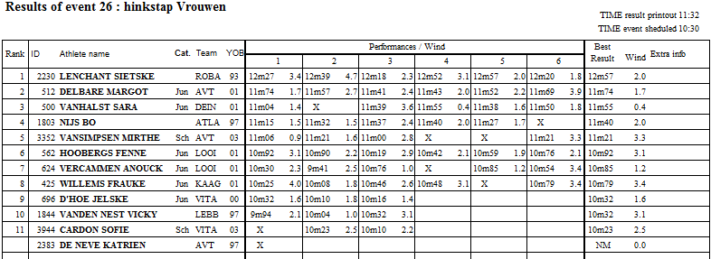

5000m Mannen Time :11:43
1 3156 SAKE NICOLAI 96 LYRA 14:49.60 KVV 1
2 2374 VAN DER KELEN WARD 94 EA 14:51.40 KVV 2
3 2876 LUNDERS MATS 91 AVT 15:05.65 KVV 3
4 2177 BIERINCKX LAURENT 95 ACHL 15:11.05
5 2510 LAMMENS WOUTER 94 DCLA 15:18.65
6 610 RASSCHAERT BJARNE 00 RCG 15:20.85
7 2154 SEVENOIS NATHAN 96 STAX 15:32.00
8 525 FERSON SIMON 01 LOOI 15:34.49
9 562 GOOSSENS WOUTER 01 EA 15:38.84
10 2272 ROBBEN TOM 95 TACT 15:42.75
11 5401 VAN LIERDE PHILIP 77 OPW 15:44.06
2618 D'HOORE SIMON 94 AVMO DNF

200m Vrouwen Reeksen Time :11:56
Heat:1 Wind : 1.5
1 2391 VERVAET IMKE 93 RCG 23.73 Q
2 646 GOOSSENS JUSTINE 00 RCG 24.44 q
3 817 VINCKE RANI 00 HAC 24.62 q
4 2481 ASOMANING STEPHANIE 90 KAAG 25.30
5 2535 KASSIMA TABITA 96 BVAC 25.55
6 1710 HOREMANS JANA 99 VMOL 25.61
7 546 VAN DER MEULEN CLOE 01 RCG 25.64

Heat:2 Wind : 2.9
1 1869 DEPUYDT MANON 97 ACME 23.61 Q
2 1743 CLAUS HANNE 99 AVMO 24.07 q
3 1752 BROSENS STEFANIE 97 ATAC 24.58 q
4 793 DE FOER LOTTE 00 ACW 25.07
5 594 VAN DER VREKEN LOTTE 01 ACW 25.35
6 2129 MERGAN TINA 99 LEBB 26.08
7 1309 HEYVAERT ELLA 05 LEBB 26.15
1823 BROEKHOVEN SASKIA 98 LOOI DNS
Heat:3 Wind : 1.9
1 1931 MEHUYS ELISE 95 LYRA 23.75 Q
2 1692 DUYCK CHARLOTTE 97 DEIN 24.18 q
3 2017 BEYLEMANS JOKE 99 ACME 24.95
4 3826 HEYVAERT LUCA 02 LEBB 25.07
5 2018 BEYLEMANS LAURA 97 ACME 25.42
6 2294 STAPPERS FLORE - 91 95 FLAC 25.99
7 2165 KINABLE CHARLOTTE 98 ROBA 26.46
8 926 KEGELS MARGOT 01 VAC 26.46

polsstok Vrouwen Time :12:12
1 424 VEKEMANS ELIEN 01 DCLA 4.00 KVV 1
2 410 DADAYEVA STEFANIE 01 RCG 3.90 KVV 2
3 837 MORREN LISE 00 RCT 3.75 KVV 3
4 417 HOOYBERGHS FLEUR 01 ACHL 3.60
4 2445 DHONT STEFFI 92 AVLO 3.60
6 1892 DE BAENE HANNE 98 OB 3.60
7 1615 JANSEN JANA 99 VMOL 3.60
8 2284 DE ROECK NELLE 93 VOLH 3.40
9 1922 VANLANGENAKER CHARLOTTE 04 RCT 3.20
2346 DECAESTEKER TATJANA 93 VAC NM

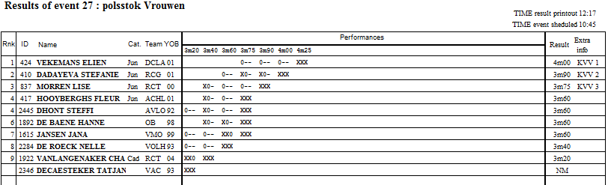

200m Mannen Reeksen Time :12:13
Heat:1 Wind : 2.7
1 2340 VLEMINCKX KOBE 98 ACHL 21.11 Q
2 2256 CALLUY DYLAN 94 OLSE 21.68 Q
3 3511 VAN HECKE CHRISTOPHE 91 EA 21.95 Q
4 2735 SCHEPERS ARNE 99 AVT 22.38
5 3372 MATHIJS BENJAMIEN 93 ACA 22.55
Heat:2 Wind : 3.4
1 2636 VERHERSTRAETEN SIMON 99 LYRA 21.77 q
2 2992 RENSON MASSIMO 96 FLAC 22.10 q
3 2963 DE PAUW BRENT 93 ACHL 22.14 q
4 3146 DE KINDER JAN 97 LYRA 22.32
5 839 BUFFEL SIMON 01 RCG 22.63
6 3338 FELIS MARTEN 97 VAC 22.85

Heat:3 Wind : 2.5
1 3479 MATTHIJS ARNOUT 87 VOLH 21.48 q
2 2935 DOOM ALEXANDER 97 AVR 21.75 q
3 3188 ROOFTHOOFT ANDREAS 96 RCT 22.20
4 789 VAN GESTEL MATTHIAS 01 ACHL 22.45
5 768 MALUMGRE WARD 00 LOOI 22.90

100mH Vrouwen Reeksen Time :12:29
Heat:1 Wind : 3.6
1 2393 MISSINNE SARAH 95 KAAG 13.29 Q
2 2553 VIDTS NOOR 96 VAC 13.69 q
3 2338 LAMMENS SHARI 96 RCG 14.33 q
4 2431 HOOYBERGHS ELIEN 95 VMOL 14.35 q
5 1795 HERMANS INE 95 AVKA 14.46
6 2527 OOSTERBOS LORE 94 AVT 14.73
Heat:2 Wind : 2.9
1 784 AGWAZIE ANGEL 01 AVLO 13.64 Q
2 2309 BEAUCARNE CHLOE 97 FLAC 13.77 q
3 2255 DE MEYER CAITLIN 99 ZWAT 14.36 q
4 536 BECK LYNN 01 KAPE 14.39 q
5 1556 LAMMENS LISA 98 ACME 14.95
6 1698 BELLEMANS INGE 95 ROBA 15.03

hinkstap Mannen Time :12:45
1 2415 DE DECKER BJORN 89 WIBO 15.36 +2.8 15.21m 1.2 KVV 1
2 2851 DE LEENHEER MATTHIAS 91 AVLO 13.67 +4.1 13.25m 1.4 KVV 2
3 2416 DE DECKER KRISTOF 91 WIBO 13.21 +2.2 12.93m 1.9 KVV 3
4 2938 AUBERT REMKO* 86 ROBA 13.08 +1.9
5 660 VAN BREEMAAT JORN 01 GENK 12.92 +2.4 12.90m 1.8
6 3314 ROMBOUTS PIETER 03 HAKI 12.37 +3.1 12.13m 1.5

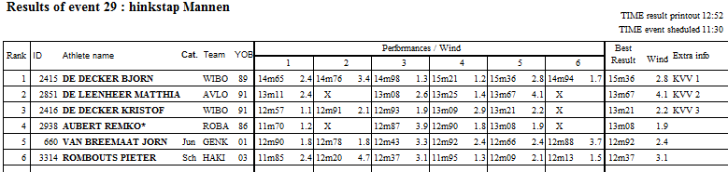

hamer Mannen Time :12:51
1 2786 MALENGREAUX REMI 95 RCG 64.86 KVV 1
2 2279 VANBROEKHOVEN STEF 97 VMOL 61.75 KVV 2
3 6375 DE WYNGAERT WALTER 70 ROBA 54.32 KVV 3
4 3355 GIEGHASE KOBE 98 VAC 52.75
5 3221 VERCAMMEN STIJN 94 HAMM 48.05
6 2549 VAN CAMPENHOUT JANNICK 91 AVKA 43.40
7 2164 GOOSSENS BJORN 87 ACHL 42.21
8 5881 BRUNINX GEERT 83 ATLA 37.59
9 6982 SNOEKS PASCAL 71 SACN 28.98

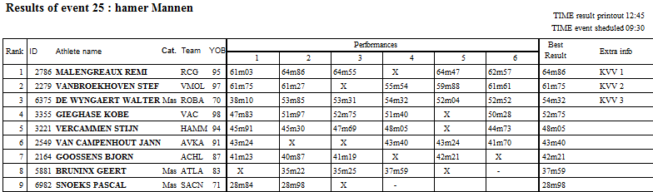

speer Vrouwen Time :13:00
1 1889 MEYLEMANS NELE 96 STAX 43.75 KVV 1
2 2230 LENCHANT SIETSKE 93 ROBA 43.49 KVV 2
3 931 TELEMANS ANN 00 AVT 43.04 KVV 3
4 1730 DE PAUW YOIKA 95 STAX 42.23
5 2307 VAN ROYEN CAROLIEN 92 ACW 40.01
6 2265 DESCHUYTTER CATO 96 KAAG 39.94
7 2166 UMANS KIRSTEN 93 HAKI 39.92
8 2431 HOOYBERGHS ELIEN 95 VMOL 38.75
9 3338 SMETS LOTTE 02 TACT 36.20
10 2492 DILLEN HIMSHA 97 WIBO 34.87
11 405 DE BLANDER LAURA 00 STAX 33.58
12 589 VAN DE SANDE AMELIE 00 OB 29.71

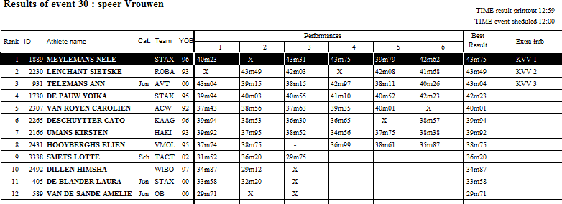

hamer Vrouwen Time :13:06
1 2185 STERCKENDRIES VANESSA 95 OEH 67.05 KVV 1
2 2409 LAGROU ILKE 98 HAC 54.61 KVV 2
3 2169 LAMBRECHT NELE 96 MACW 47.23 KVV 3
4 479 VERCRUYSSE EVI 01 DCLA 46.43
5 2502 VANBAELENBERGHE WEGE 99 RCG 44.30
6 845 DEWULF INEZ 01 HAC 44.18
7 2425 CLAES EVELYNE 98 RCT 43.12
8 698 DAEMS LOTTE 00 ZWAT 41.14
9 2283 VAN KEMSEKE JODIE 99 VOLH 40.80
10 766 VAN PUYVELDE JANA 01 VOLH 40.66
11 656 GOOSSENS WIEBE 01 OLSE 37.60

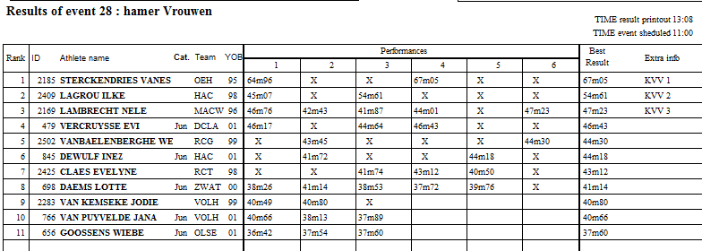

discus Mannen Time :14:31
1 2310 SPILLIAERT STIJN 93 HAMM 52.90 KVV 1
2 2204 NYS EDWIN 86 DCLA 52.59 KVV 2
3 3221 VERCAMMEN STIJN 94 HAMM 47.43 KVV 3
4 7219 PEETRAIN FILIP 74 OEH 46.19
5 3453 TRUYTS TIMOTHY 89 ACBR 44.15
6 3239 WAGEMANS JARNO 89 HAMM 42.68
7 3029 FRIJTERS PIETER 90 LYRA 40.81
8 3233 ENGELS LORENZ 86 VOLH 37.41
9 3290 PARMENTIER THOMAS 92 DEIN 32.28
10 455 VAN HAUTEM MIDAS 01 STAX 30.79

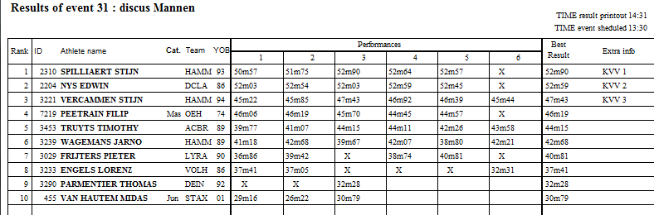

110mH Mannen Finale Time :14:34
Wind : 1.4
1 3505 MAES SANDER 92 AVT 14.28 KVV 1
2 2822 SEGERS SENNE 95 LYRA 14.85 KVV 2
3 2999 DUMON EWOUT 95 KAAG 14.89 KVV 3
4 3524 GEUSKENS WILLEM 95 LYRA 14.95
5 2401 JACOBS SVEN 97 EA 15.11
6 2950 THIRY CHRISTOPHE 96 DAC 15.23
7 3121 CEULEMANS YANNICK 94 ACBR 16.01
8 2937 CEULEMANS SEPPE 99 ROBA 16.25

100mH Vrouwen Finale Time :14:43
Wind : 1.4
1 2393 MISSINNE SARAH 95 KAAG 13.45 KVV 1
2 784 AGWAZIE ANGEL 01 AVLO 13.68 KVV 2
3 2553 VIDTS NOOR 96 VAC 13.71 KVV 3
4 2309 BEAUCARNE CHLOE 97 FLAC 13.76
5 2255 DE MEYER CAITLIN 99 ZWAT 14.30
6 2338 LAMMENS SHARI 96 RCG 14.54
7 536 BECK LYNN 01 KAPE 14.58
8 2431 HOOYBERGHS ELIEN 95 VMOL 14.80

100m Mannen Finale Time :14:53
Wind : 2.6
1 2329 VRANKEN ANDREAS 93 DCLA 10.58 KVV 1
2 531 KERKHOFS NIELS 01 AVT 10.84 KVV 2
3 798 SAERENS MAARTEN 00 HAKI 10.95 KVV 3
4 477 VERGAELEN DRIES 00 RCG 10.96
5 3041 SCHELDEMAN YESTIN 91 RCG 11.06
6 3372 MATHIJS BENJAMIEN 93 ACA 11.11
7 3511 VAN HECKE CHRISTOPHE 91 EA 11.13
2254 HOFMANS VICTOR 94 OLSE DNS

100m Vrouwen Finale Time :15:03
Wind : 1.0
1 482 ROSIUS RANI 00 AVT 11.77 KVV 1
2 817 VINCKE RANI 00 HAC 11.88 KVV 2
3 646 GOOSSENS JUSTINE 00 RCG 11.95 KVV 3
4 793 DE FOER LOTTE 00 ACW 12.12
5 2017 BEYLEMANS JOKE 99 ACME 12.13
6 465 VAN LENT LOTTE 01 AVZK 12.20
7 3826 HEYVAERT LUCA 02 LEBB 12.26
8 2535 KASSIMA TABITA 96 BVAC 12.42

1500m Vrouwen Time :15:17
1 1557 SCHAEVERBEKE AXANA 95 ACME 4:39.81 KVV 1
2 1886 SCHREURS ANNE 92 GENK 4:40.48 KVV 2
3 2048 VAN BOXSTAEL BIRGIT 88 EA 4:45.80 KVV 3
4 1377 ENKELS HANNAH 05 LOOI 4:45.91
5 1609 LAUWERS SOFIE 91 RAM 4:48.84
6 480 LEMMENS BRITT 01 AVT 4:49.48
7 2584 PINTER ELINE 96 ACME 4:50.99
8 1454 VERVOORT CHARLOTTE 04 LYRA 4:51.75
9 2059 HENS EVY 91 ROBA 4:53.12
10 1843 MEERT SORAYA 93 LEBB 4:54.27
11 4124 RAHME MONA 78 DCLA 4:56.11
12 3669 BICKER JANNE 02 ABES 4:57.20
13 1939 POLLENTIER JELENA 97 HCO 5:04.78
14 2395 VAN LAETHEM DELPHINE 95 LEBB 5:06.16
15 1551 WAERZEGGERS BRIDEY 98 ACKO 5:16.69
16 1147 MERTENS HASSE 04 LAT 5:27.25

1500m Mannen Time :15:24
1 2225 VALGAEREN SAM 90 HULS 3:53.85 KVV 1
2 2413 VAN SCHOUBROECK JONAS 92 ARAC 3:54.58 KVV 2
3 735 DEWULF LENNERT 01 RCG 3:56.71 KVV 3
4 2695 AERSSENS DIETER 95 DCLA 3:57.07
5 2206 VAN DER BURGT THIJS 94 RCG 3:58.11
6 602 CLAESEN ARON 01 ATLA 4:03.38
7 469 PAUWELS THOMAS 00 KAAG 4:08.74
8 484 VAN DEN SCHOOR SENNE 01 AVZK 4:14.83
9 2800 GIJBELS JOAS 02 AVT 4:15.94
2336 DERBOVEN THOMAS 92 HULS DNF

hoog Vrouwen Time :15:29
1 831 GOOSSENS ZITA 00 DEIN 1.75 KVV 1
2 3488 VAN DEN BRANDE LAURA 03 AVKA 1.68 KVV 2
2 1976 CANTERS GRETEL 99 AVT 1.68 KVV 3
4 3496 CICILIA RUNE 02 ATLA 1.60
5 415 COENE JACEY 01 SACN 1.60
6 2388 VANKERCKHOVEN SARAH 95 SPBO 1.55
7 603 ALGOET BRITT 01 HCO 1.55
7 1079 DRIJKONINGEN MIRTHE 04 BREE 1.55

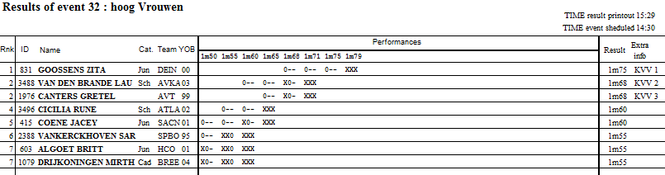

ver Vrouwen Time :15:36
1 2553 VIDTS NOOR 96 VAC 6.06 +1.8 KVV 1
2 1752 BROSENS STEFANIE 97 ATAC 5.97 +3.4 5.70m 1.1 KVV 2
3 1803 NIJS BO 97 ATLA 5.93 +2.1 5.64m 1.2 KVV 3
4 2239 COPPENOLLE EMMA 96 DEIN 5.63 +2.0
5 1795 HERMANS INE 95 AVKA 5.59 +2.6 5.27m 1.4
6 2262 TESSENS HELENA 95 LYRA 5.25 +2.3 5.00m 1.8
7 695 GEERTS SIEN 01 LYRA 5.22 +1.0
8 1844 VANDEN NEST VICKY 97 LEBB 4.91 +2.8 4.86m 1.6
9 603 ALGOET BRITT 01 HCO 4.81 +3.4
10 810 DEBROCK ELISE 01 AVT 4.74 +2.4

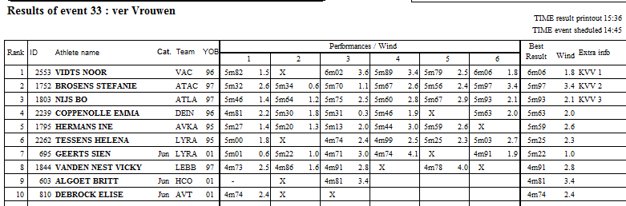

3000m Steeple Mannen Time :15:39
1 519 VANDERPOORTEN MARCO 00 HAMM 9:33.86 KVV 1
2 2710 WINDERICKX RUBEN 94 AVT 9:43.81 KVV 2
3 2271 ROBBEN SIMON 99 TACT 9:54.78 KVV 3
4 5682 HENDRICKX WANNES 78 VMOL 11:01.65

3000m Steeple Vrouwen Time :15:59
1 1747 SPEELMAN-ROOMS FEMKE 99 ATAC 11:07.77 KVV 1
2 1768 VAN HOOREBEKE JOLIEN 94 RIEM 11:10.97 KVV 2
3 476 HELLINGS NIENKE 01 AVT 11:15.92 KVV 3
4 2004 MEYLAERS ANTSE 99 AVT 11:31.13
5 576 SPIESSENS JANA 01 SPBO 12:52.76
6 514 HERNES ILONA 01 AVT 14:01.27

kogel Vrouwen Time :16:06
1 1730 DE PAUW YOIKA 95 STAX 13.52 KVV 1
2 420 DEFRERE ELENA 01 DCLA 13.44 KVV 2
3 1564 HELSEN ELISE 98 ACHL 13.32 KVV 3
4 3756 VERLINDEN SOPHIE 79 WIBO 12.24
5 851 SAVELKOULS MILA 00 ATLA 11.97
6 2557 VANTHILLO LYNN 89 ACBR 11.59
7 698 DAEMS LOTTE 00 ZWAT 11.37
8 647 PIERI AXELLE 01 ATLA 10.92
9 543 DANIELS LIENE 01 ATLA 10.32
10 2550 VERVAET PAULIEN 94 VOLH 10.16

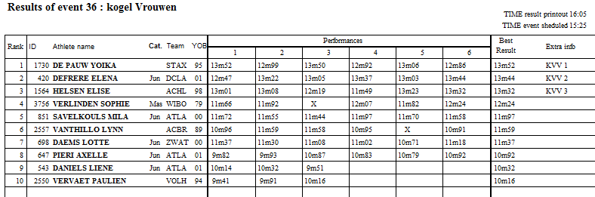

800m Vrouwen Time :16:07
1 1841 HELLINCKX LOTTE 95 LEBB 2:12.54 KVV 1
2 1055 KLUSKENS JANA 04 LAT 2:13.53 KVV 2
3 1762 CORNELIS JACINTHA 98 RIEM 2:14.60 KVV 3
4 1054 KLUSKENS ELENA 04 LAT 2:18.00
5 1356 PEUSENS FIEN 04 ATLA 2:18.48
6 1558 DE MEYER JOLIEN 93 RCG 2:18.87
7 2117 DECORTE MALOE 93 ASVO 2:25.80
8 3480 SERRE SOFIE 03 LOOI 2:28.78
9 3358 MEEUS MARTHE 02 ARAC 2:29.69
10 3854 DE BOCK MARIE 02 VOLH 2:29.97

800m Mannen Time :16:20
1 2593 SCHOCKAERT LAURENS 90 LAT 1:56.67 KVV 1
2 3264 VAN LAETHEM GAETAN 97 LEBB 1:56.80 KVV 2
3 568 VAN LOOY RUBEN 01 ARAC 1:57.58 KVV 3
4 502 VANHERCK JORNE 00 VMOL 1:57.96
5 3437 DIERCKX TOON 87 VOLH 1:58.42
6 2798 DUIJSTERS GORAN 02 AVT 1:58.59
7 3085 BECKERS WIM 98 AVT 1:59.76
8 2440 DE PROFT MICHIEL 90 LEBB 2:00.89
9 2597 DE BACKER GERBEN 95 LAT 2:01.99
10 767 VERHEIJEN ROBBE 01 LOOI 2:02.23
11 2437 BOEYKENS ARNE 97 LAT 2:03.53
12 2289 ROOSENBOOM BRYAN 93 LAT 2:18.45
polsstok Mannen Time :16:15
1 2199 BROEDERS BEN 95 DCLA 5.58 KVV 1
2 2190 AUSLOOS FREDERIK 96 DCLA 5.00 KVV 2
3 2326 VAN NUFFELEN THOMAS 98 DCLA 5.00 KVV 3
4 3435 VANLANGENAKER JULES 02 RCT 4.80

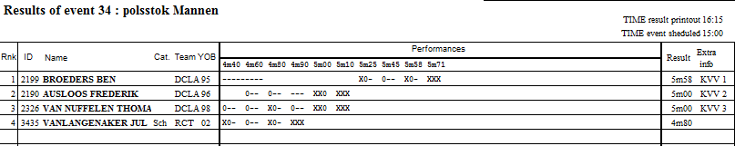

speer Mannen Time :16:30
1 2956 HERMAN TIMOTHY 90 ACME 80.48 KVV 1
2 845 SORGELOOS CEDRIC 00 ACW 78.10 KVV 2 BR JUN
3 599 WILDEMEERSCH ROBBE 00 ACME 66.93 KVV 3
4 3123 VAN DEN BOSCH VINCENT 89 BRAB 66.80
5 3164 MORY NIEL 99 OEH 64.44
6 2198 BROEDERS ARNE 93 DCLA 63.44
7 3433 DUCHATEAU JARNE 96 BRAB 63.00
8 3587 MEEUSEN DRIES 96 WIBO 60.94
9 2699 GROBBEL JACOB 98 DCLA 58.98
10 2675 BOGAERTS JONAS 94 LEBB 58.26
11 746 DE BLOCK WARD 01 ACW 53.39
12 2626 MAES MICHIEL 99 AVMO 52.94

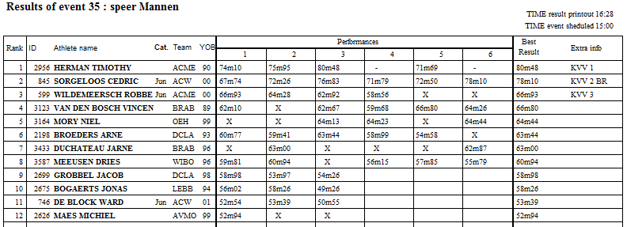

200m Vrouwen Time :16:30
Wind : 3.2
1 2391 VERVAET IMKE 93 RCG 23.24 KVV 1
2 1931 MEHUYS ELISE 95 LYRA 23.54 KVV 2
3 1869 DEPUYDT MANON 97 ACME 23.57 KVV 3
4 1692 DUYCK CHARLOTTE 97 DEIN 23.77
5 1743 CLAUS HANNE 99 AVMO 24.07
6 1752 BROSENS STEFANIE 97 ATAC 24.45
7 817 VINCKE RANI 00 HAC 24.95
646 GOOSSENS JUSTINE 00 RCG DNS

200m Mannen Time :16:38
Wind : 2.1
1 2340 VLEMINCKX KOBE 98 ACHL 21.23 KVV 1
2 2636 VERHERSTRAETEN SIMON 99 LYRA 21.65 KVV 2
3 2935 DOOM ALEXANDER 97 AVR 21.66 KVV 3
4 3479 MATTHIJS ARNOUT 87 VOLH 21.72
5 2256 CALLUY DYLAN 94 OLSE 22.06
6 2992 RENSON MASSIMO 96 FLAC 22.13
3511 VAN HECKE CHRISTOPHE 91 EA DNF

ver Mannen Time :16:54
1 3147 BROOTHAERTS MATHIAS 94 LYRA 7.41 +3.1 7.35m 0.7 KVV 1
2 2731 ANNYS NICOLAS 94 AVKA 7.00 +2.9 6.92m 0.7 KVV 2
3 2851 DE LEENHEER MATTHIAS 91 AVLO 6.84 +3.2 6.62m 1.9 KVV 3
4 812 VANDERSTEEN YENTE 00 AVT 6.69 +2.2 6.53m 1.4
5 2788 COENE LARS 02 KAAG 6.66 +4.3 6.55m 1.7
6 2675 BOGAERTS JONAS 94 LEBB 6.45 +5.1 0.00m 0.0
7 2937 CEULEMANS SEPPE 99 ROBA 6.45 +4.0 5.35m 1.8
8 964 COLIGNON TIM 01 VAC 6.24 +2.8 0.00m 0.0
9 1275 SIJBERS SASHA 04 SACN 6.12 +2.1 0.00m 0.0
660 VAN BREEMAAT JORN 01 GENK NM +0.0
2767 BOSCHMANS JURIAN 94 AVKA NM +0.0

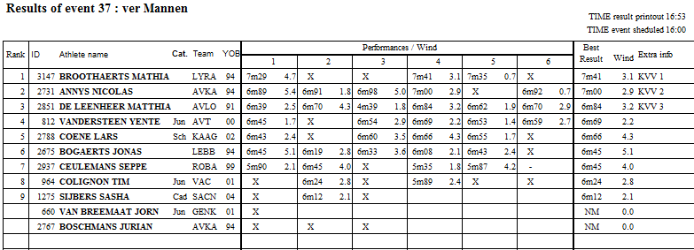

400m Vrouwen Rechtstr. Finale Time :16:55
Heat:1
1 1639 VAN DER GAAST LORE 97 AVT 58.87
2 2156 FLOSSY STIEN 98 RCT 59.26
3 2454 DEGREVE ROBIN 97 OEH 59.32
4 3548 BIESEMANS FIEN 03 SPBO 60.00
5 1734 JULES SEGERS LIENE 93 ARAC 60.10
6 1684 VAN DE VELDE SOFIE 98 DUFF 60.33
7 535 UYTTERSPROT EMMA 01 LEBB 67.46
1619 GOETSCHALCKX MIEKE 96 VMOL DIS R.163.3
Heat:2
1 2420 GAYE KINE 98 RCG 54.63 KVV 1
2 604 PONETTE HELENA 00 HCO 55.50 KVV 2
3 1716 ROSSAERT MIREILLE 90 ACW 56.46 KVV 3
4 2348 ROSSAERT ISAURA 92 ACW 57.01
5 2020 VALCK MAURY 97 RCG 57.28
6 1615 JANSEN JANA 99 VMOL 58.25
7 1601 BRUYNEEL HELEN 91 AZW 59.04
8 1674 VOET ENYA 92 DCLA 59.61

400m Mannen Rechtstr. Finale Time :17:07
Heat:1
1 861 PLASSCHAERT COBE 00 VOLH 51.50
2 793 HEYLEN ROBBERT 00 LIER 51.78
3 855 VEROFT REIDAR 01 ABES 52.25
4 2360 BELLEMANS KOEN 93 ROBA 52.30
5 3422 CLAES KOBE 94 AVT 52.93
6 3088 LATINNE REYNALDO 92 AVT 55.20
638 VAN AERDE JOREN 01 KAAG DIS R.125.5
Heat:2
1 3385 VAN DE VOORDE GERBEN 90 ACW 50.38
2 3040 RENDERS ROBBE 97 ARAC 50.43
3 3043 VAN HERCK YONI 93 ARAC 51.03
4 2574 VANATTENHOVEN MATTHIAS 92 DCLA 51.62
5 3242 LEMOUCHE LINDERT 97 LYRA 51.63
6 3184 PIETERS CHRISTOF 86 ACW 51.92
7 2804 ROELANTS WARRE 02 ALVA 52.86
Heat:3
1 2294 VRIJSEN VINCENT 89 AVT 49.06 KVV 1
2 2634 IGUACEL CHRISTIAN 96 LYRA 49.08 KVV 2
3 3384 ROSSAERT MICHAEL 95 ACW 49.32 KVV 3
4 2774 DOTREMONT KEVIN 95 DCLA 49.58
5 690 DE NEEF MILAN 01 ROBA 50.14
6 2473 MONSEREZ DYLAN 97 KKS 50.16
7 3489 LAPORTE VINCENT 97 AVZK 50.63

hoog Mannen Time :17:12
1 3256 JACOBS BRETT 94 AVZK 2.04 KVV 1
2 2247 VERDONCK EMILE 95 AZW 2.04 KVV 2
3 3290 PARMENTIER THOMAS 92 DEIN 1.95 KVV 3
4 2401 JACOBS SVEN 97 EA 1.95
5 918 VERMEIREN JEF 00 ACHL 1.95
6 3070 VERSMISSEN BART 87 VMOL 1.95
7 817 MAREELS MILAN 01 OLSE 1.90
8 2891 ANNAERT WOUTER 94 AVT 1.85
2657 GHUYS BRAM 93 OEH NM
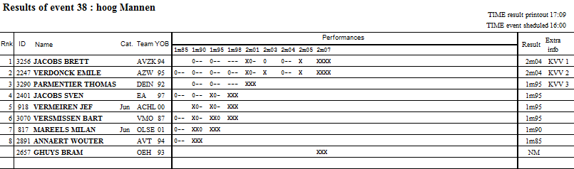

kogel Mannen Time :17:20
1 2630 QUINTELIER MATTHIAS 97 AVKA 17.35 KVV 1
2 2310 SPILLIAERT STIJN 93 HAMM 16.41 KVV 2
3 3410 VLASSAK MAX 97 ATLA 16.37 KVV 3
4 3239 WAGEMANS JARNO 89 HAMM 15.96
5 2837 VAN WAES BRECHT 95 AVLO 15.51
6 3453 TRUYTS TIMOTHY 89 ACBR 14.56
7 3029 FRIJTERS PIETER 90 LYRA 14.26
8 3394 VAN STEEN JOANNES 95 VOLH 14.13
9 2327 VERBEYLEN KASPER 99 DCLA 13.96
10 2549 VAN CAMPENHOUT JANNICK 91 AVKA 13.82
11 3505 MAES SANDER 92 AVT 13.23
12 455 VAN HAUTEM MIDAS 01 STAX 10.56

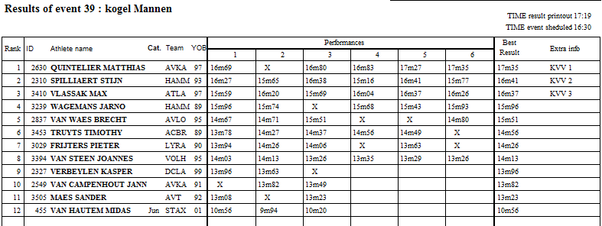

400mH Vrouwen Rechtstr. Finale Time :17:28
Heat:1
1 2518 VANDORPE AXELLE 95 AVLO 62.73
2 2151 SCHETS KJENTA 97 OEH 63.30
3 731 CROMPHOUT MARTHA 01 VAC 66.64
4 641 VIERENDEELS LOIKE 01 LEBB 66.77
5 3507 LEJON HELENE 02 SPBO 68.34
6 2207 VERSTRAETE CHARLIE 97 FLAC 70.46
7 861 VANHEST AUKJE 01 LOOI 79.25
Heat:2
1 1650 VANBESIEN FLAVIE 95 FLAC 60.54 KVV 1
2 1842 TCHIMOU BENEDIKT 99 RAM 60.98 KVV 2
3 2466 DEWYNGAERT PAULIEN 97 ROBA 61.89 KVV 3
4 1764 HEMELSOET LARA 96 RIEM 62.48
5 508 THYSSEN LISSE 01 ACW 62.63
6 2524 KISOKA PEGUY 97 ZWAT 63.41
7 2329 DE WIN DINJA 91 DAC 65.22

400mH Rechtstr. Finale Mannen Time :17:37
Heat:1
1 3077 DE MEULEMEESTER BEN 99 ZWAT 56.95
2 2408 LANSSENS MICHIEL 95 AVT 57.90
3 941 VAN PUT VINCENT 01 ZWAT 58.11
4 732 DE SCHRYVER CHRISTOPHE 01 VAC 58.44
5 3259 ZEPHIRIN JOACHIM 85 KKS 59.27
6 2172 LOCKEFEER QUINTEN 99 LAT 62.60

Heat:2
1 2892 OWUSU DYLAN 97 RCG 51.05 KVV 1
2 3097 STROOBANTS JORI 89 VITA 51.98 KVV 2
3 2680 BRAS TUUR 99 OEH 52.93 KVV 3
4 2747 VAN OOST LOIC 95 AVR 54.23
5 2777 HANJOUL DENIS 91 DCLA 54.99
6 2931 PEETERS DRIES 99 ACBR 55.13

discus Vrouwen Time :17:48
1 2240 HELLEBUYCK ANOUSKA 89 DEIN 49.82 KVV 1
2 851 SAVELKOULS MILA 00 ATLA 47.04 KVV 2
3 420 DEFRERE ELENA 01 DCLA 46.54 KVV 3
4 2149 BOLDRINI SIMONA* 86 OEH 44.78
5 1580 EMMERZAAL JILL* 90 DCLA 42.84
6 761 NAUDTS ANKE 01 VOLH 41.42
7 2557 VANTHILLO LYNN 89 ACBR 39.48
8 543 DANIELS LIENE 01 ATLA 38.01
9 647 PIERI AXELLE 01 ATLA 37.58
10 1922 VANLANGENAKER CHARLOTTE 04 RCT 36.99
11 1689 DE BUSSCHER JANA 96 DEIN 34.81
12 1865 PEETERS NELE 97 AVKA 34.19

